This n That

An e-mail newsletter from Agapé Athletics Club

Editor: Marieta Bortoli 082 466 7031 03 June 2019 www.agape.org.za

E-mail: marietabortoli@gmail.com

NB

- Next league race – 29 June
- Agapé race (Jacaranda City Challenge) – 12 October. Members to assist. PLEASE DIARIZE !!!!!!

Editorial

The only race in Pretoria is a relay at Supersport Park in Centurion at 07h30. There are 3 different distances. For further information you can contact Renee Jordaan 083 230 9963 or Jaco Dorfling 082 699 4383.

Our gazebo will not be at the race as Hennie and Marix is off to KZN to support our Comrades runners.

I will attach the list of awards winners next week as my document is too large and will not be delivered to all recipients.

Notice Board Additions

◊ Glenfair Boulevard Race of Friendship
◊

Attachments

□

Birthday Greetings

May your birthday bring joy, contentment and may the Lord’s blessing surround you.
Mag jy in hierdie nuwe lewensjaar ‘n innerlike vrede ken wat jou in staat sal stel om die eise en behoeftes van elke dag in die seker wete van die Heer se teenwoordigheid tegemoet te gaan.

Lizzy Oberholzer 03 June | Jaco Pretorius 03 June
Carla Greyling 04 June | Lourens Erasmus 07 June
Claude Smit 09 June | BZ Stewart 12 June
Gerhard Stoop 18 June | Josias van der Merwe 21 June
Elise Loubser 24 June | Rikus Kellerman 27 June
Lesogo Motlogedi 28 June | Madelein Greef 29 June
Audrey Lenoge 29 June

Personalia

Welcome new and former members

In the mailbox

General
Clothing available:
Buffs @ R100
Ladies skirts @ R200
Second skins @ R220
Age tags @ R30
The items will also be available at races, please visit our gazebo or contact Marix at 072 541 7268

Congratulations

Congratulations to the following members:

More photos taken at our awards function

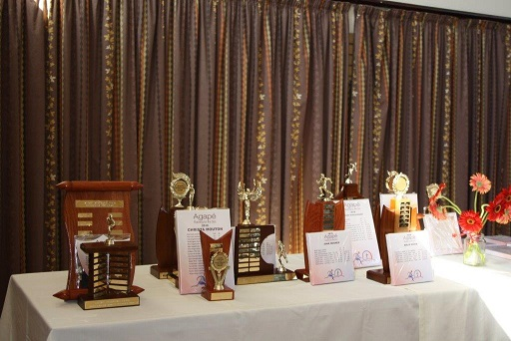

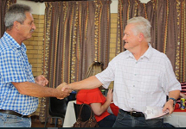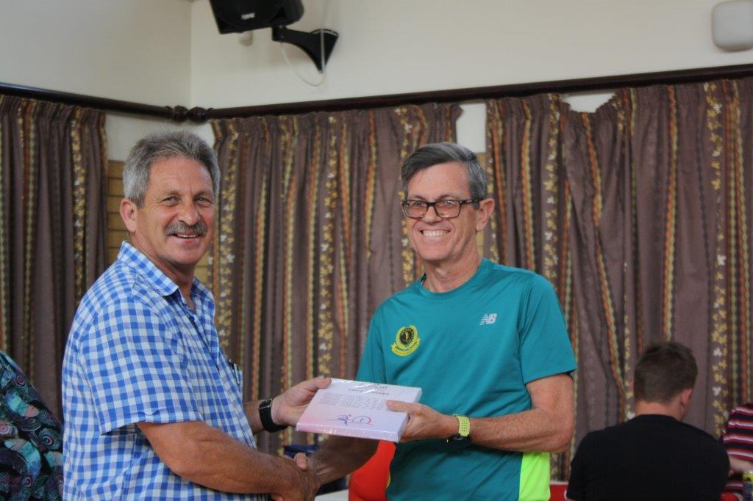
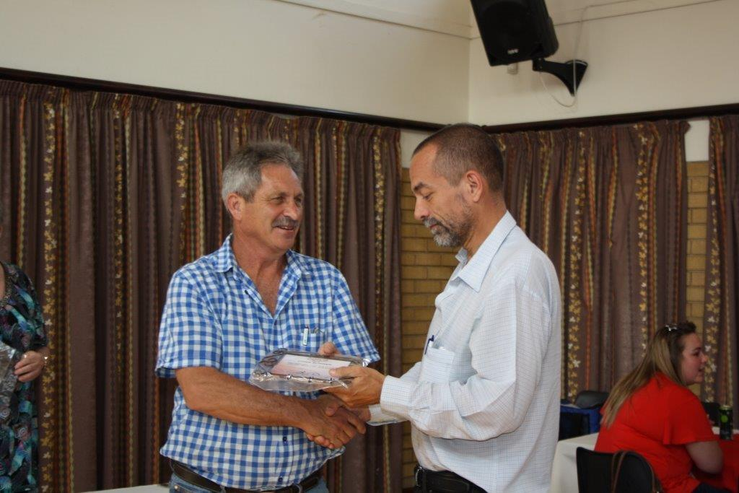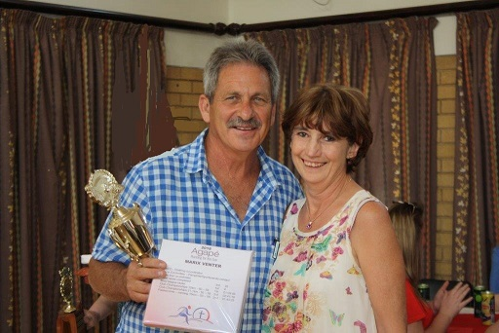
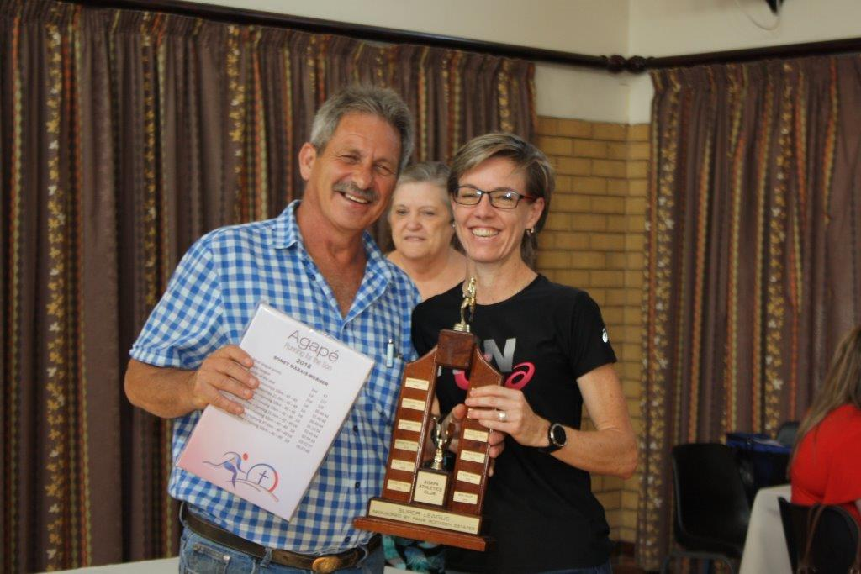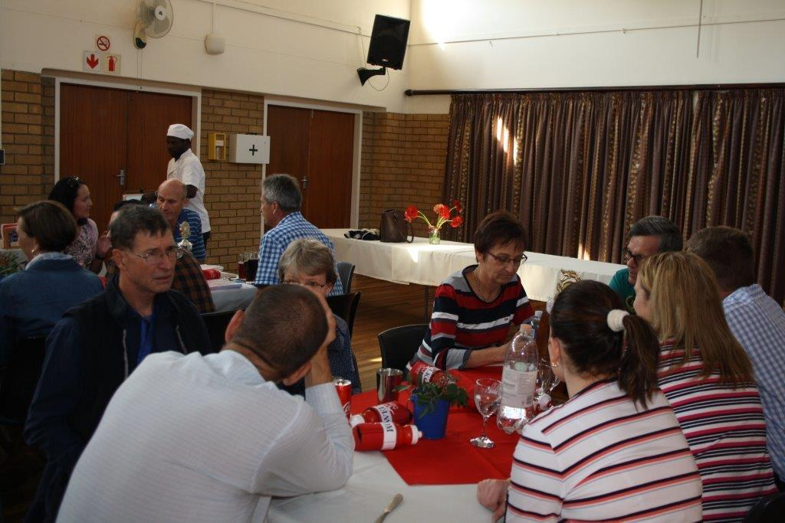
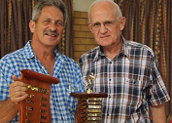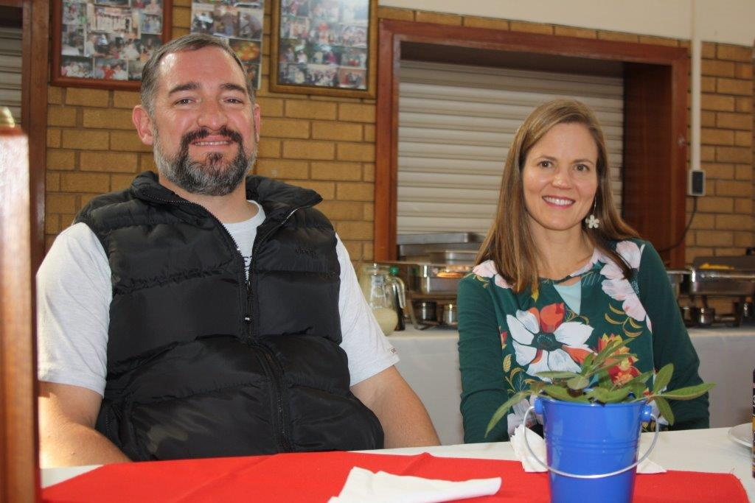
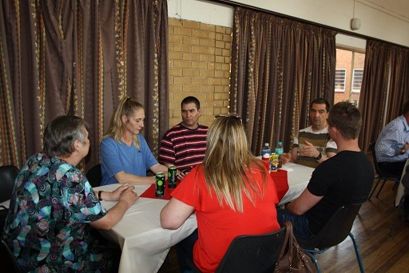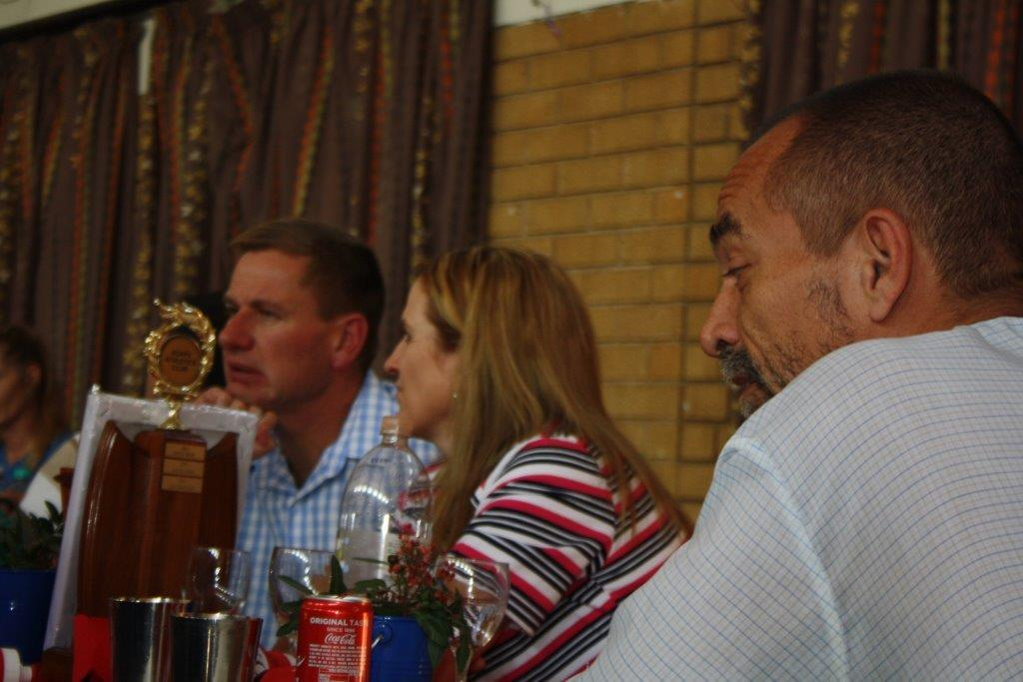

Thank you’s

Race reports

Race report feedback, Race for Faith, Silver Oaks Crossing, 1 June 2019, 15 km race (Elbert Loubser):


Arrived at 05:50, the parking area adjacent to the running lanes were already filled. Was not able to park close to the gazebos this year. :-( There was a serious chill in the air. Cold (7 Celsius), yes, but not as cold as it was in 2018. The three walls Hennie raised provided a much needed 'comfy cove'.
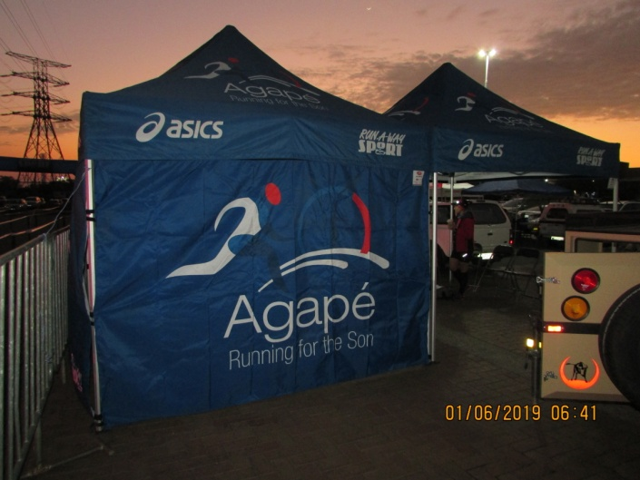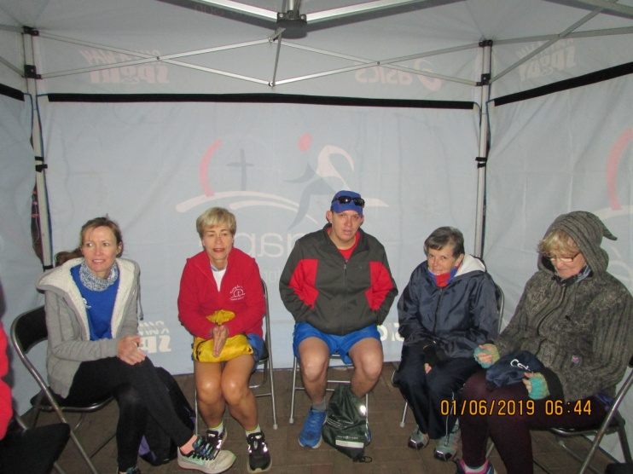

To get to the start is not 'straight forward'. One first needs to move North, out of shopping area and then head East (behind the buildings of the shopping centre), then still a couple of meters South, to eventually arrive at the START in the street Johann Pl(ace). The 10 kay and 15 kay races were on their way at 07:00, turned East in Von Backstrom Blvd.

From there one does many twists and turns through the streets of the Silver Lakes Golf Estate with beautifully styled houses. Most residents wisely still tucked in the warmth of their beds. The route mostly flat with intermittent rises and falls. Just after the 8-kilometre board, the 10 kay race splits left. The 15-kay race carries on straight and then does a huge circle anti-clockwise via Guinea Fowl and Fish Eagle Streets. The latter affords one a view of one of the 'lakes' and the game area, before it turned into an off-road section between the 10 kay and 11 kay boards. The off-road part adjacent to the security wall/fencing, had three major hills. Was able to fleetingly spot a buck. One returned back through the wall to 'civilization' and tarred road onto Kingfisher Cres(cent) around the 13-kay board. A right into Hoopoe Cres and then a left into George Blvd, which brought one back towards Von Backstrom Blvd. One retraced one's steps on Johann Pl, swooped behind and around the rear end of Dros, to the Finish under the Run-A-Way Sport arch.

Thank you, Hennie, and Marix for the base station gazebos (with walls), which presented a necessary buffer against the chill.

Thank you to Run/Walk for Life club, Silver Lakes Golf Estate, McCarthy Volkswagen Silver Oaks, Bidvest and all the other sponsors for presenting a pleasant race. Much appreciated.

Agape greetings.

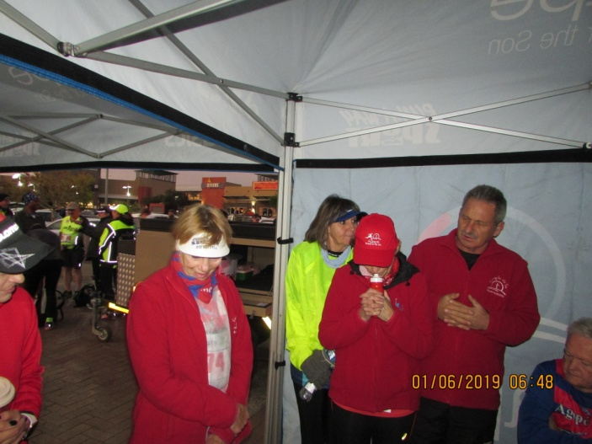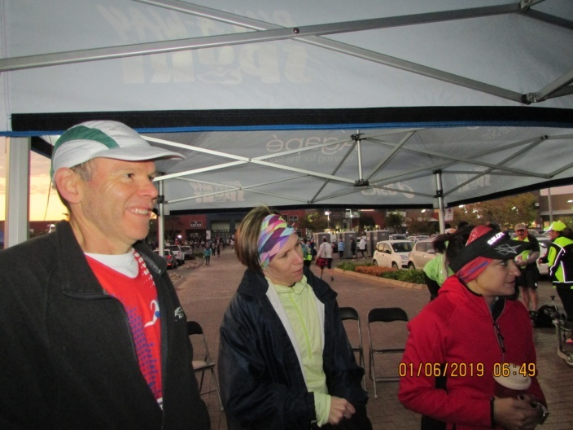
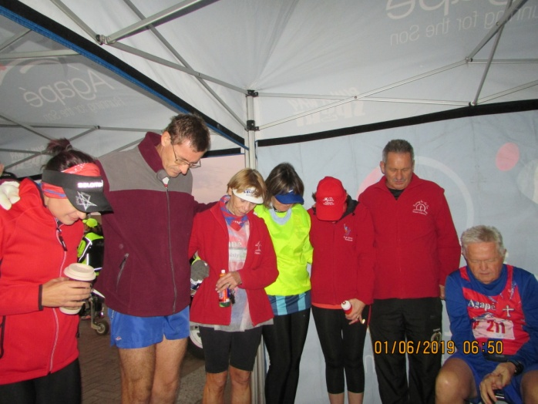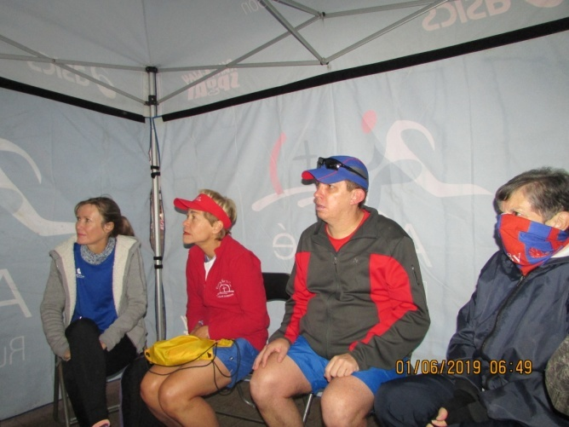

Following photos (courtesy Gina's cellphone), Lammie the impromptu photographer:

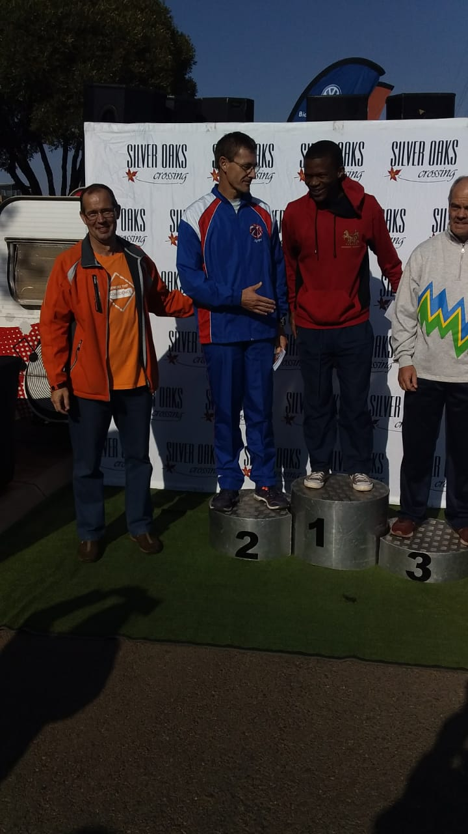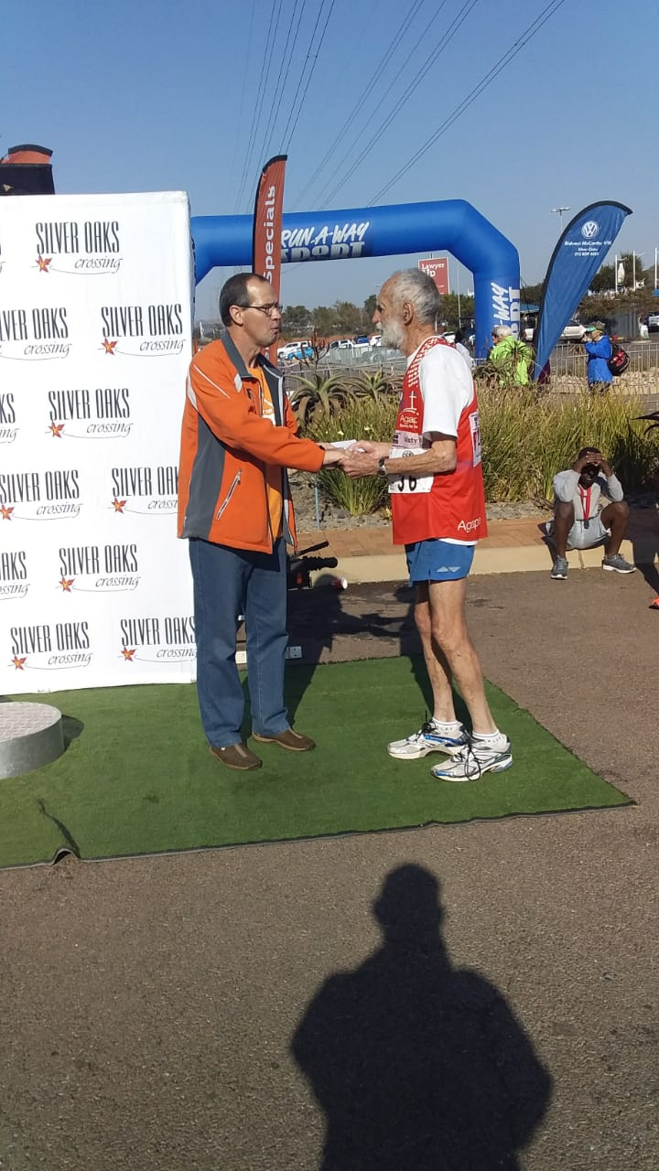
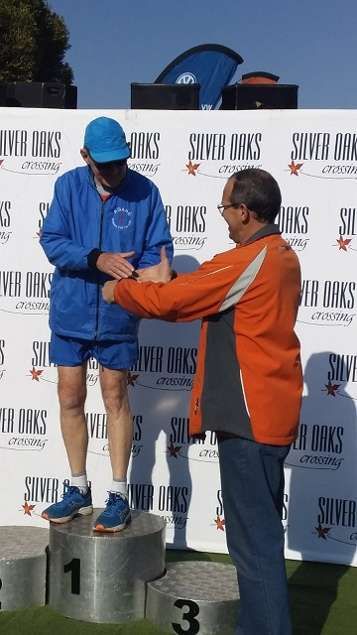

Race Results
Superspar Hercules Skosana (AGN) 10km race - 2019-05-25
Position | Initials | Surname | Sex | Age | Finish Time
49 | L | Leshaba | M | 18 | 00:43:47
57 | J | Pokwane | M | 47 | 00:44:23
74 | W | Kiewitt | M | 51 | 00:45:24
129 | D | De Beer | M | 47 | 00:48:32
130 | C | Burger | M | 54 | 00:48:37
239 | L | Fourie | M | 74 | 00:54:37
244 | E | Fourie | F | 52 | 00:54:46
440 | P | Coetzee | M | 69 | 01:03:52
439 | W | Weder | M | 70 | 01:03:52
451 | B | Boyes | F | 54 | 01:04:14
452 | T | Oelofse | F | 44 | 01:04:15
533 | D | Frost | M | 63 | 01:09:22
694 | M | Venter | F | 57 | 01:19:37
783 | S | Bothma | M | 45 | 01:27:07
Superspar Hercules Skosana (AGN) 21km race - 2019-05-25
Position | Initials | Surname | Sex | Age | Finish Time
153 | L | Madondile | M | 36 | 01:50:48
164 | E | Rabotse | M | 33 | 01:52:09
183 | J | Van Der Merwe | M | 50 | 01:52:54
413 | A | Manganye | M | 62 | 02:17:18
423 | M | Van Der Walt | M | 48 | 02:19:56
439 | T | Lenoge | M | 40 | 02:21:47
440 | A | Lenoge | F | 40 | 02:21:51
506 | A | Te Reh | M | 69 | 02:31:54
Superspar Hercules Skosana Walk (AGN) 10km race - 2019-05-25
Position | Initials | Surname | Sex | Age | Finish Time
14 | J | Barkhuizen | M | 49 | 01:07:13
15 | L | Klopper | M | 54 | 01:07:13
38 | C | Mouton | F | 63 | 01:22:51
Superspar Hercules Skosana Walk (AGN) 21km race - 2019-05-25
Position | Initials | Surname | Sex | Age | Finish Time
4 | G | Brink | M | 53 | 02:05:06
Race of Faith (AGN) 10km race - 2019-06-01
Position | Initials | Surname | Sex | Age | Finish Time
26 | M | Schafer | M | 51 | 00:46:28
69 | J | Van Der Merwe | M | 49 | 00:54:02
72 | L | Fourie | M | 74 | 00:54:23
75 | C | Smit | M | 67 | 00:54:41
149 | A | Moolman | F | 31 | 01:00:51
151 | M | Boudouris | F | 37 | 01:00:57
180 | K | Nurden | M | 85 | 01:03:16
183 | Z | Hattingh | F | 38 | 01:03:26
232 | L | Klopper | M | 54 | 01:07:12
254 | P | Coetzee | M | 68 | 01:07:54
407 | M | Venter | F | 59 | 01:22:32
408 | H | Venter | M | 59 | 01:22:32
440 | S | Bothma | M | 45 | 01:27:26
Race of Faith (AGN) 15km race - 2019-06-01
Position | Initials | Surname | Sex | Age | Finish Time
161 | M | Malan | F | 60 | 01:22:26
201 | G | Brink | M | 52 | 01:24:07
205 | A | Lenoge | F | 45 | 01:24:33
206 | T | Lenoge | M |  | 01:24:41
396 | C | Burger | M | 54 | 01:37:02
416 | G | Hughes | F |  | 01:38:07
419 | E | Van Zyl | F | 41 | 01:38:15
477 | A | Te Reh | M | 69 | 01:43:35
569 | L | Erasmus | M | 78 | 01:52:55
682 | E | Loubser | M | 62 | 02:18:45

League results

Training/Health snippets

Bodyworks: Black Toenail (Sub-Ungual Haematoma)

How to recognise it, how to overcome it
Symptoms
You’ll notice a painful, hot toe after a run in new shoes or without socks. This may then cause discomfort in any shoes.
Signs
Your nail turns dark red or black due to blood underneath. This happens because the constant bruising during your run causes the blood vessels under your nail to leak. No medical investigations are required.
What else could it be?
A mild case could be confused with an ingrowing toenail, fungal nail infection or other disease such as psoriasis.
Self-treatment
If you’re courageous enough, make a needle red-hot and let it burn through the centre of the nail, about 3-5mm up from the base to relieve the pent-up blood underneath. You can squeeze out the rest of the blood by hand.
Medical treatment
If you’re lacking bravery, let your doctor perform the above operation! They may then prescribe antibiotics to prevent infection, and you can take paracetamol for pain.
Can you run through it?
Yes, to an extent, though pain will prevent you from overdoing it. If you don’t treat the problem, it will bleed more, and you’ll probably lose your toenail.
Recovery time
You should be able to run a few days after treatment, especially if you use a plaster to tape the nail down (this may later drop off to be replaced by new growth). To prevent recurrence, make sure that your shoes are comfortable, spacious and properly worn-in – and wear socks.

Your thought for the week

Improve what you can and accept all the rest of life just as it comes.

Your smile for the week

I dreamed I was forced to eat a giant marshmallow. When I woke up, my pillow was gone.

==

"Can you please hold my hand?" a mother asks her son: "Anton, do you think I’m a bad mom?"
-
Son: "My name is Paul."

==

On a mountain trip a man falls down into a crack. His wife calls after him, “Are you OK?”
-
“Yeah!”
-
“Are you hurt?”
-
“No!”
-
“Not a scratch? How come?!“
-
“I’m not done falling yet-et-et-et-et!”

Something to ponder over / something spiritual

The Least of These

It was a cold winter's day that Sunday. The parking lot to the church was filling up quickly. I noticed as I got out of my car that fellow church members were whispering among themselves as they walked to the church.

As I got closer, I saw a man leaned up against the wall outside the church. He was almost lying down as if he was asleep. He had on a long trench coat that was almost in shreds and a hat topped his head, pulled down so you couldn't see his face.

He wore shoes that looked 30 years old, too small for his feet. With holes all over them, his toes stuck out. I assumed this man was homeless and asleep, so I walked on by through the doors of the Church.

We all enjoy fellowship for a few minutes, and then someone brought up the man who was lying outside. People snickered and gossiped, but no one bothered to ask him to come in, including me. A few moments later, church began. We all waited for the preacher to take his place and give us The Word when the doors to the church opened. In came the homeless man, walking down the aisle with his head down.

People gasped and whispered and made faces. He made his way down the aisle and up onto the pulpit. When he took off his hat and coat, my heart sank. There stood our preacher. He was the "homeless man".

No one said a word. The room was silent and still.

The preacher took his Bible and laid it on the stand.

"Folks, I don't think I have to tell you what I'm preaching about today. Jesus said, 'Truly I tell you, whatever you did for one of the least of these brothers and sisters of mine, you did for me.'" He proceeded to preach a sermon about treating others with dignity and kindness even if they seem to be the "least".

Cancelled Races

Notice Board

Useful Links:
www.raceresults.co.za/flyers - for the latest race pamphlets
www.agn.co.za/#League for the latest league logs and the league points you earned

Saturday 15 June Executive Mayor Race (Morula ½ marathon) 10/5 km
Race Organisers: Morula Athletics Club
Venue: Giant Stadium, R80 Road to Soshanguve

 | 10 km | 5 km
Entry fee | R 60 | R 50
Entry fee 70+ | Free – race day only
Start Time | 07:00 | 07:15
Cut-off | 03:30
No Pets
No iPods or listening devices are allowed
No wheelchair athletes

Pre-entries at: Run-A-Way Sports; Tshwane Running Store; Sportsman’s Warehouse Atterbury & Kolonnade

www.entrytime.com

AGN 10km Championships
Saturday 22 June Fara Winter Challenge 10/5 km
Race Organisers: Faranani Athletics Club
Venue: Rietondale Park, c/o van der Merwe & Soutpansberg Rd, Rietondale

 | 10 km | 5 km
Entry fee | R 80 | R 50
Start Time | 07:00
Cut-off | ??

No Pets
No iPods or listening devices are allowed

Pre-entries at: Run-A-Way Sports; Tshwane Running Store; Sweatshop Southdowns

League Race
Saturday 29 June Glenfair Boulevard Race of Friendship 21.1/10/5 km
Race Organisers: Run/Walk for Life
Venue: c/o Lynnwood & Daventry Rd, Lynnwood Manor

 | 21.1 km | 10 km | 5 km
Entry fee | R 90 | R 70 | R 50
Start Time | 07:00
Cut-off | 03:00

No Pets
No iPods or listening devices are allowed

Pre-entries at: Lone Hawk Spur

www.enteronline.co.za

2019 AGN LEAGUE FIXTURE LIST
EVENT | DISTANCE | DATE | LEAGUE
 |  |  | RR | RW
Race of Friendship | 21.1/10 km | 29/06/19 | X | X
Zwartkop Road Race | 21.1/10 km | 27/07/19 | X | X
Spirit of Flight | 10 km | 31/08/19 | X | X
Brooklyn Road Race | 21.1/10 km | 07/09/19 | X | X
Capital Classic | 21.1/10 km | 05/10/19 | X | X
Freedom of Expression | 21.1/10 km | 02/11/19 | X | X

Masters Athletics Fixture list

South Africa
10 August 2019 Mpumalanga Secunda
? October 2019 Rassies Bronkhorstspruit
25/26 October 2019 SWD Oudtshoorn
8/9 November 2019 Free State Bloemfontein

South African Championships
April/May 2020 Central Gauteng Herman Immelman

Africa Championships
2021 Nairobi, Kenya
2023 South Africa

International Championships
28/9 - 6/10 2019 30th Summer universiade Naples, Italy
20/7/2020 – 1/8/2020 World Masters athletics Champs Toronto, Canada

Time Trials:

Centurion - Wednesdays at 17:30
Lewende Woord Centurion
Contact Marinda 654 5800 (h) / 082 720 9017

Zita Park - Tuesdays at 17:30
Zita Street, Zita Park, Garsfontein
Contact Hennie Venter – 082 676 6792

Gazebo Enquiries

Hennie Venter – 082 676 6792

INTERCESSOR



Jaco Barkhuizen 083 519 1737

Agapé Executive 2018/2019

Name | Position | Telephone number | E-mail address
Hennie Venter | Chairperson | 082 676 6792 | henniev@seng.co.za  venterhennie08@gmail.com
Hennie Venter | Registrar & Club Captain | 082 676 6792 | venterhennie08@gmail.com
Marieta Bortoli | Treasurer & Vice chairperson | 082 466 7031 | marietabortoli@gmail.com
Marieta Bortoli | Secretary & Editor | 082 466 7031 | marietabortoli@gmail.com
De Wet de Beer | Race organizer & PRO | 082 373 2987 | dewet@styletechnique.co.za
Jaco Barkhuizen | Intercessor | 083 519 1737 | jaco00028@gmail.com
Marix Venter | Clothing co-ordinator & General activities | 072 541 7268 | ventermarix9@gmail.com
Gustav Brink | Statistician | 083 417 8431 | gustav.brink@gmail.com

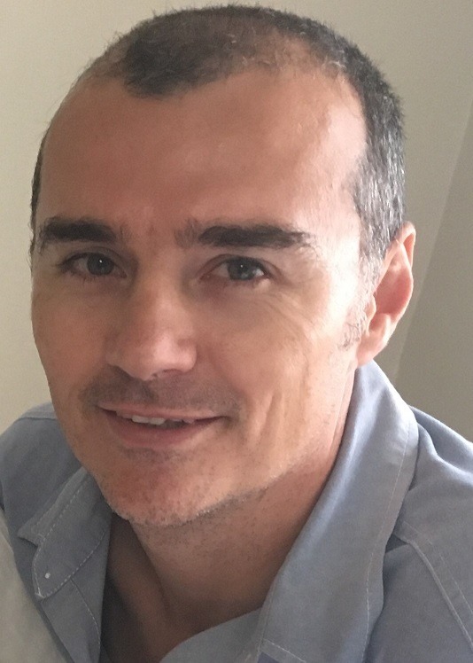
Hennie Venter Marieta Bortoli De Wet de Beer
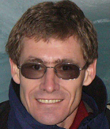
Jaco Barkhuizen Marix Venter Gustav Brink (Ex-officio)

